**API Testing Assignment - Postman**

**Assignment 1:**

1. Download and Install Postman.

2. Register and login with your email account.

3. Create a workspace named “PostmanBeginner”.

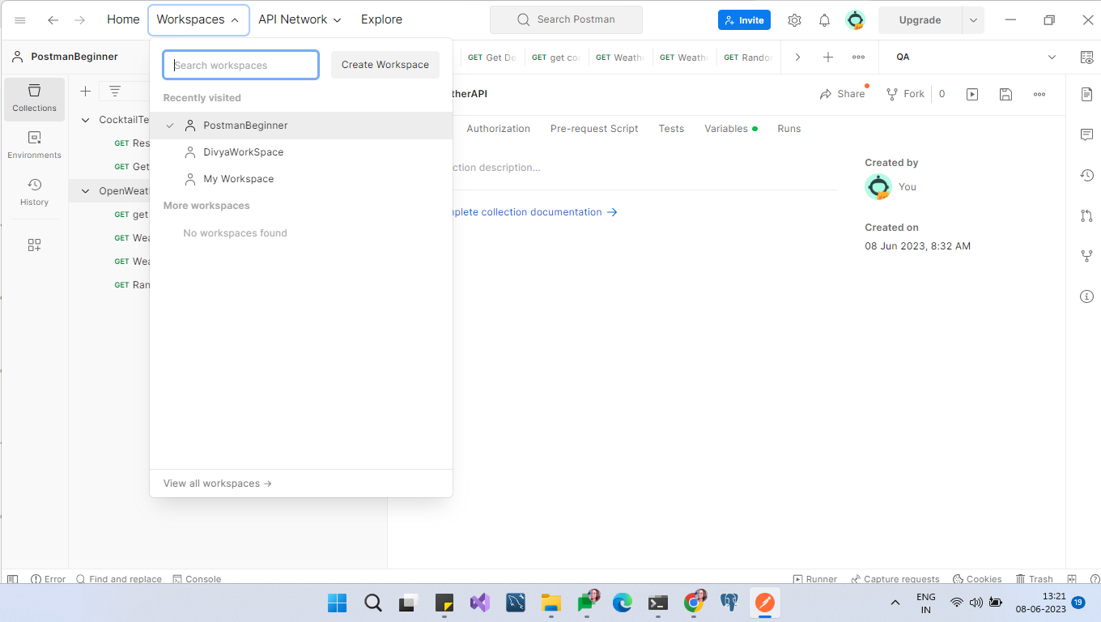

**Assignment 2:**

● Create Test for API -

<https://www.thecocktaildb.com/api/json/v1/1/search.php?s=margarita>

Tests:

1. Test that the response time is within the time duration as specified in the requirement/

API specification (for our test we may settle for 3 seconds).

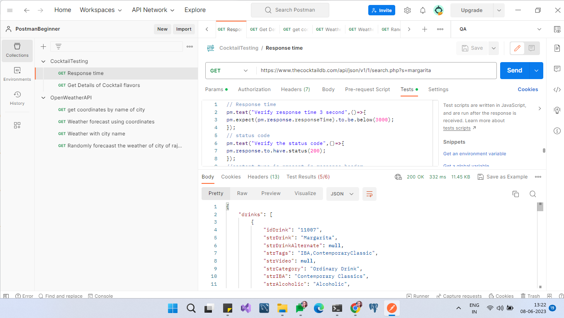

2. Test for status code (should be 200).



3. Test that 'content-type' field is present in response headers.

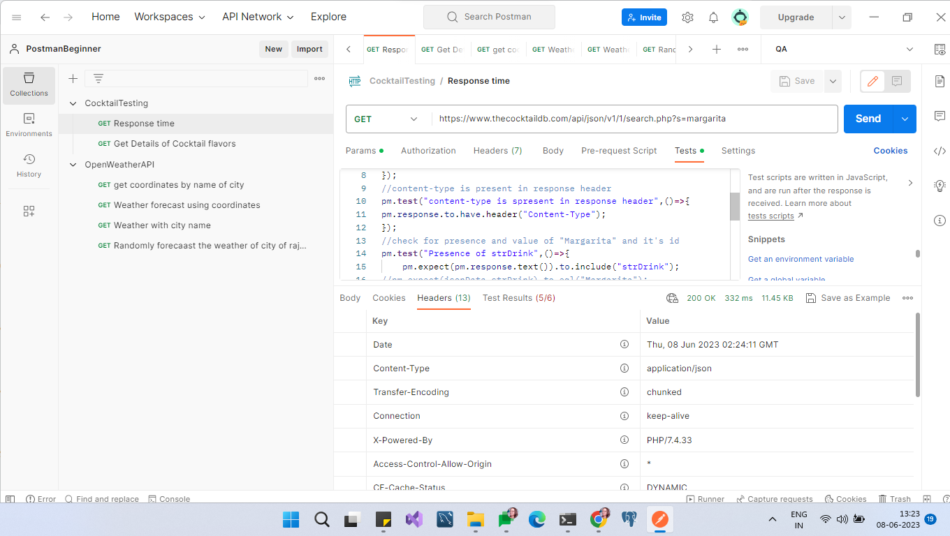

4. Test for presence (and its value) of 'Margarita' field and its id.

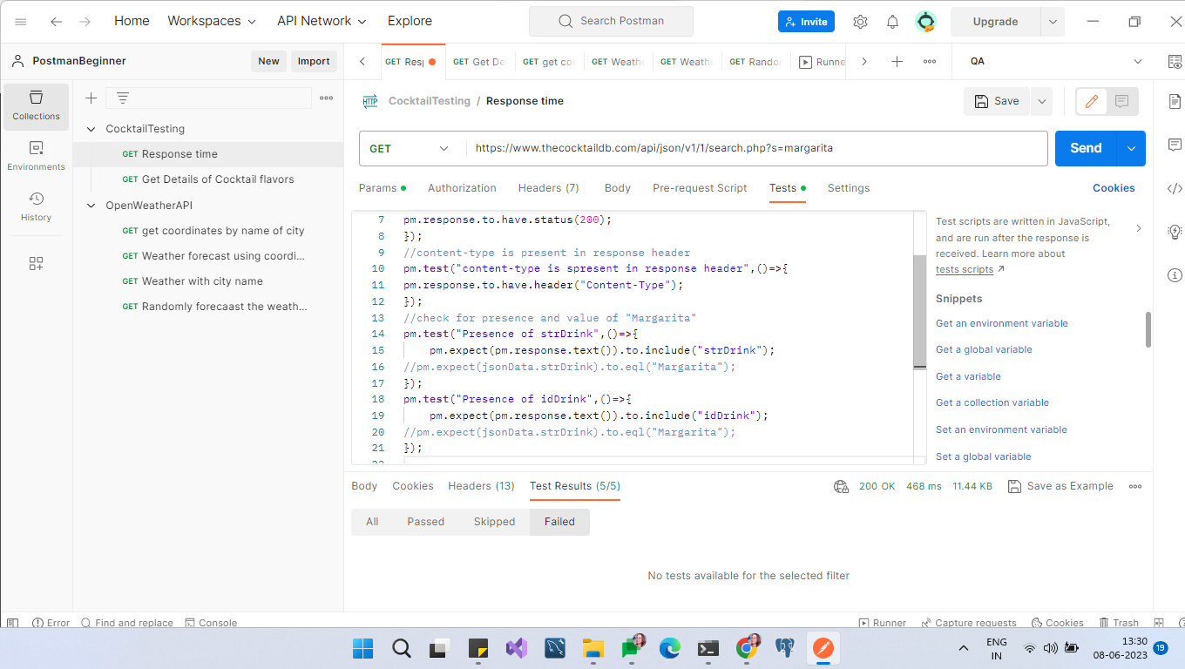

5. Get the details of the different cocktail flavors.

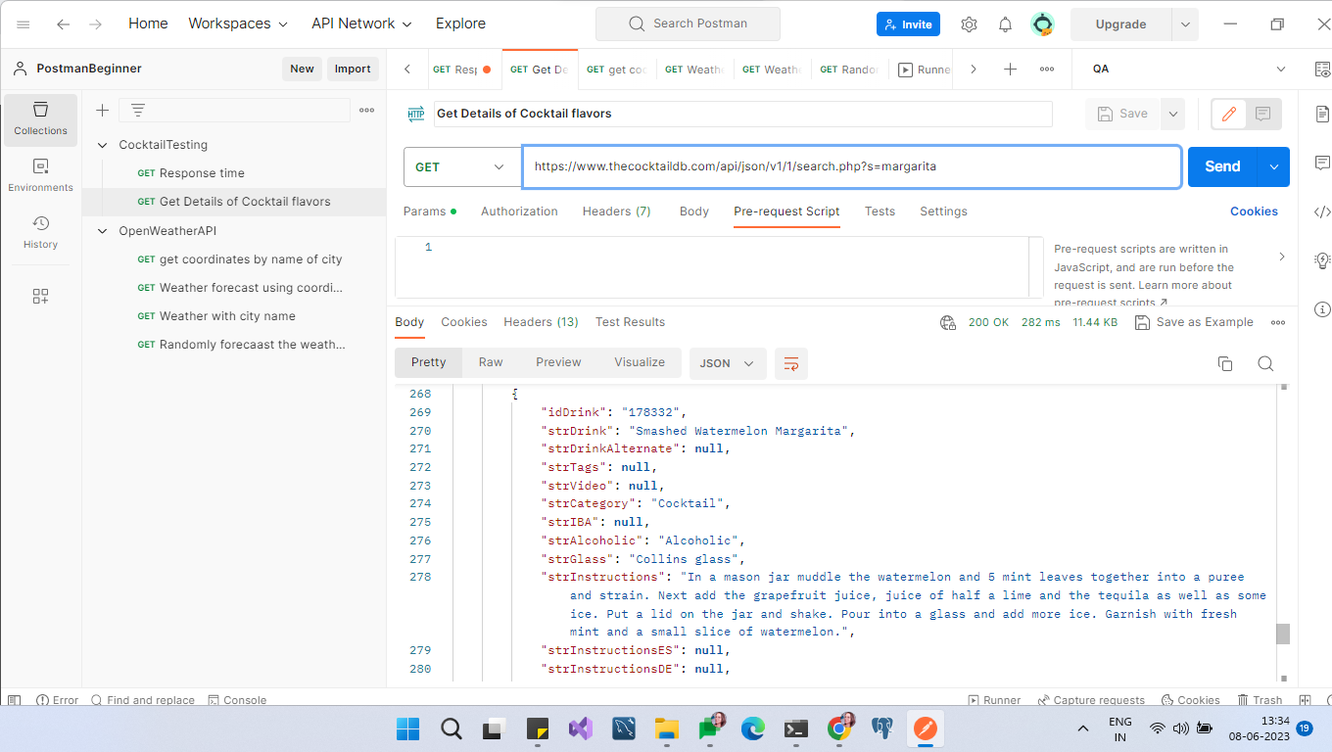

Source:

<https://www.thecocktaildb.com/api.php>

**Assignment 3: Exploring the Openweather API**

6. Visit https://openweathermap.org/api and sign up to get your own API key.

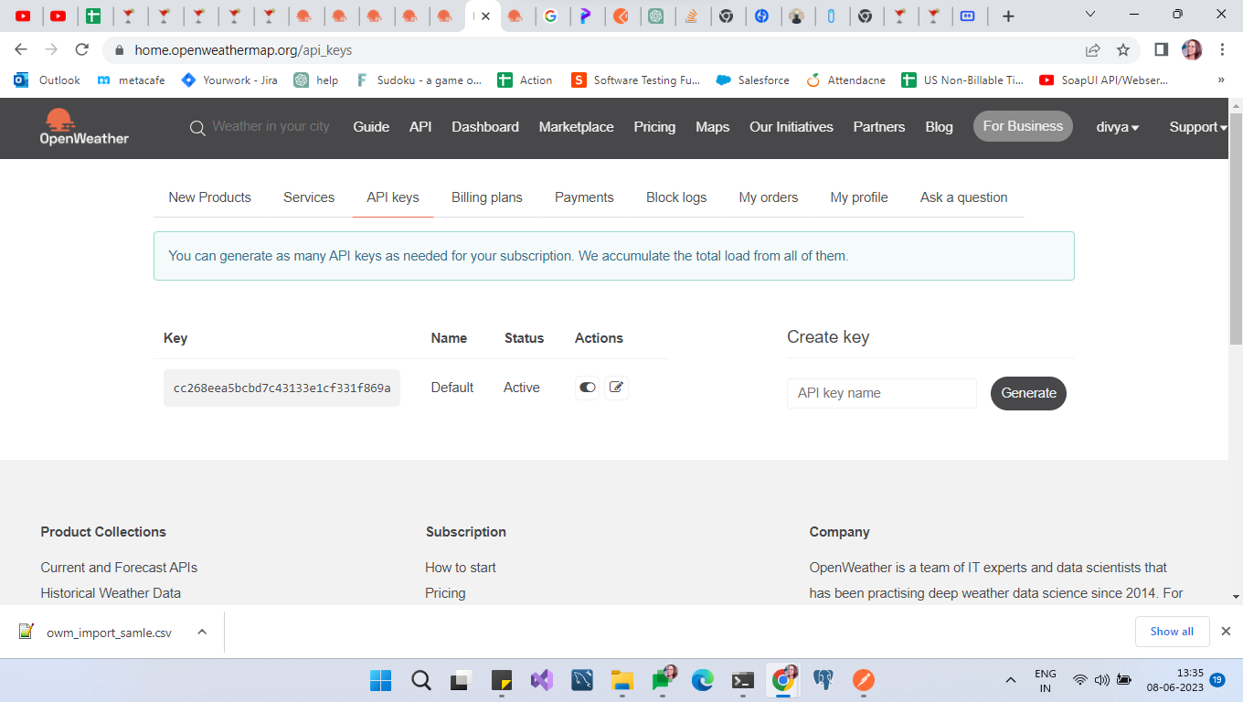

7. Find the id of a city of your choice (search the site, you should find it).

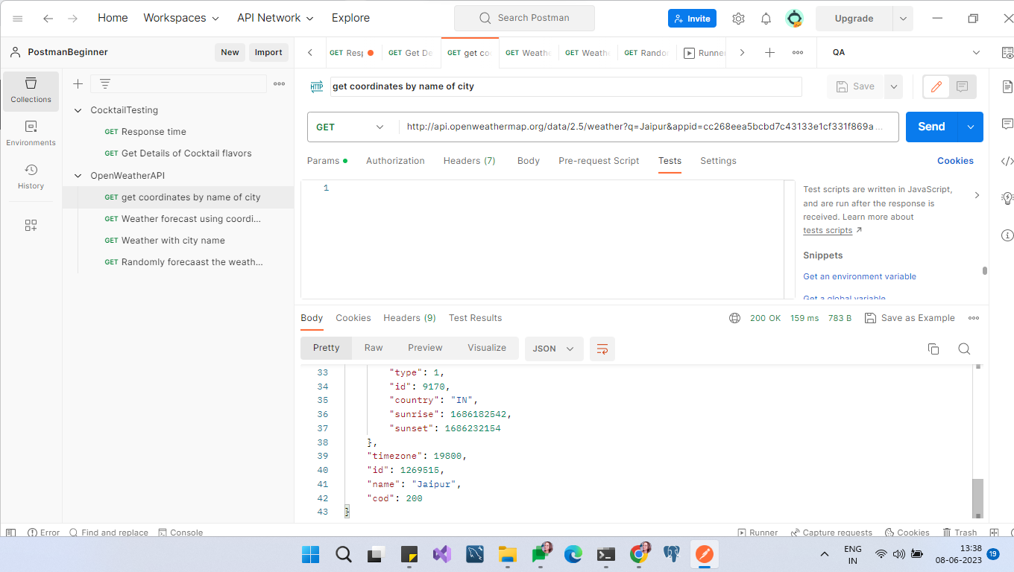

8. Create a collection of requests and make use of pre-request scripts and environment

variables in your collection.

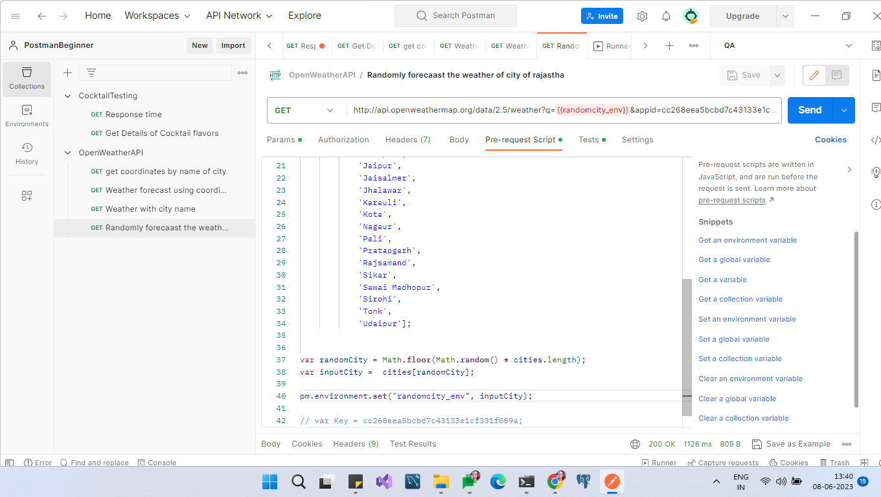

9. Write a couple of requests to find as much information you can using the

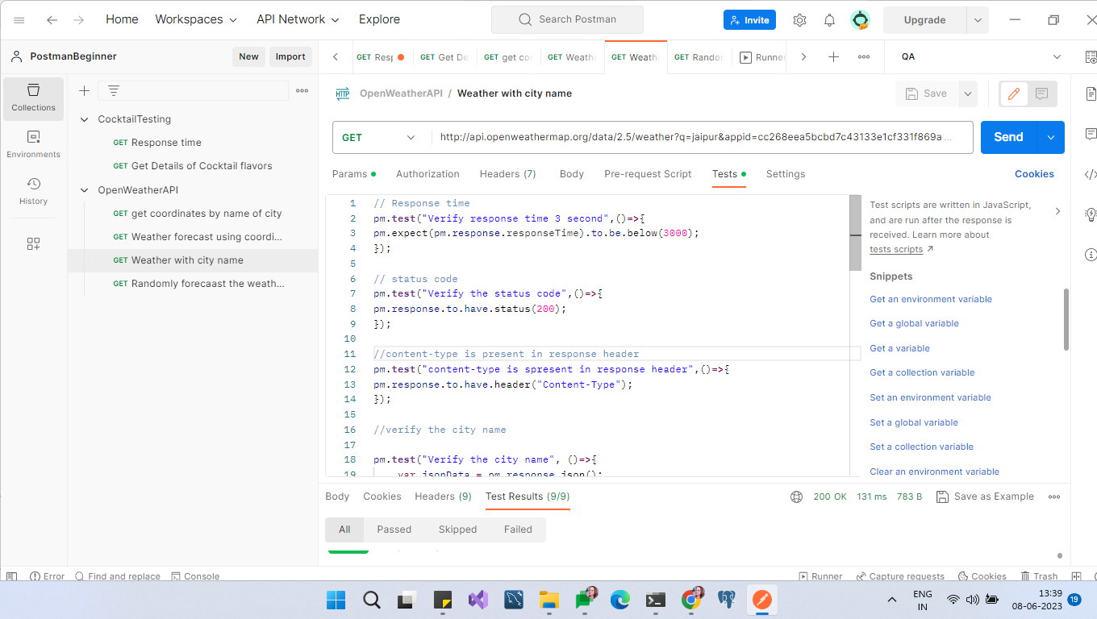

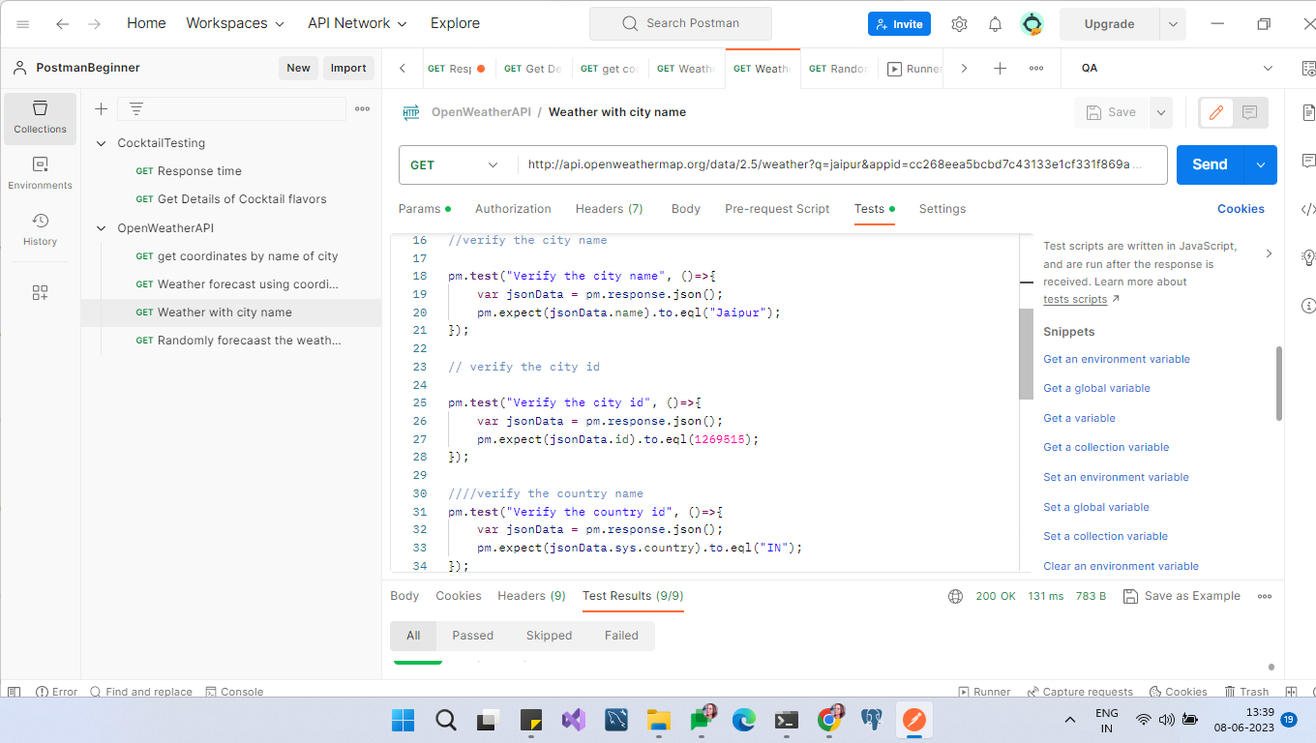

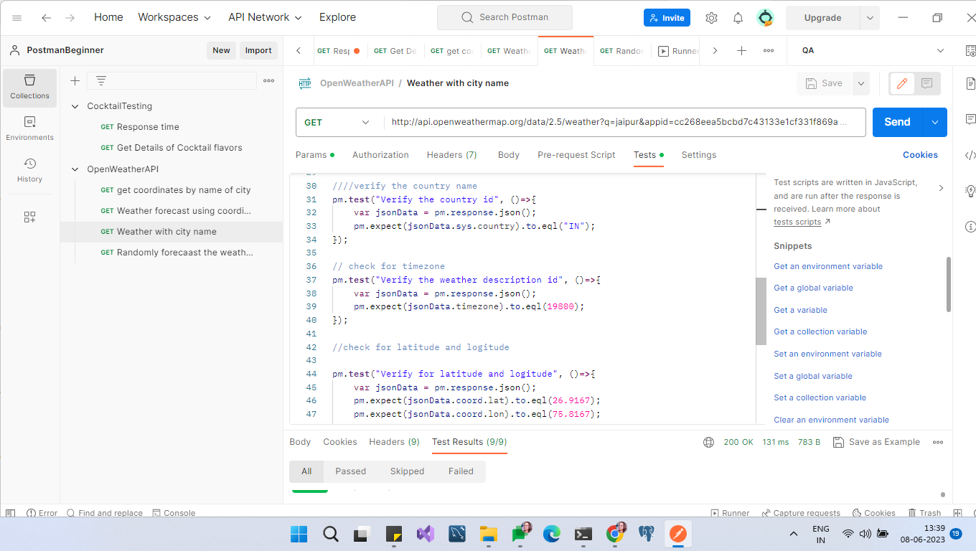

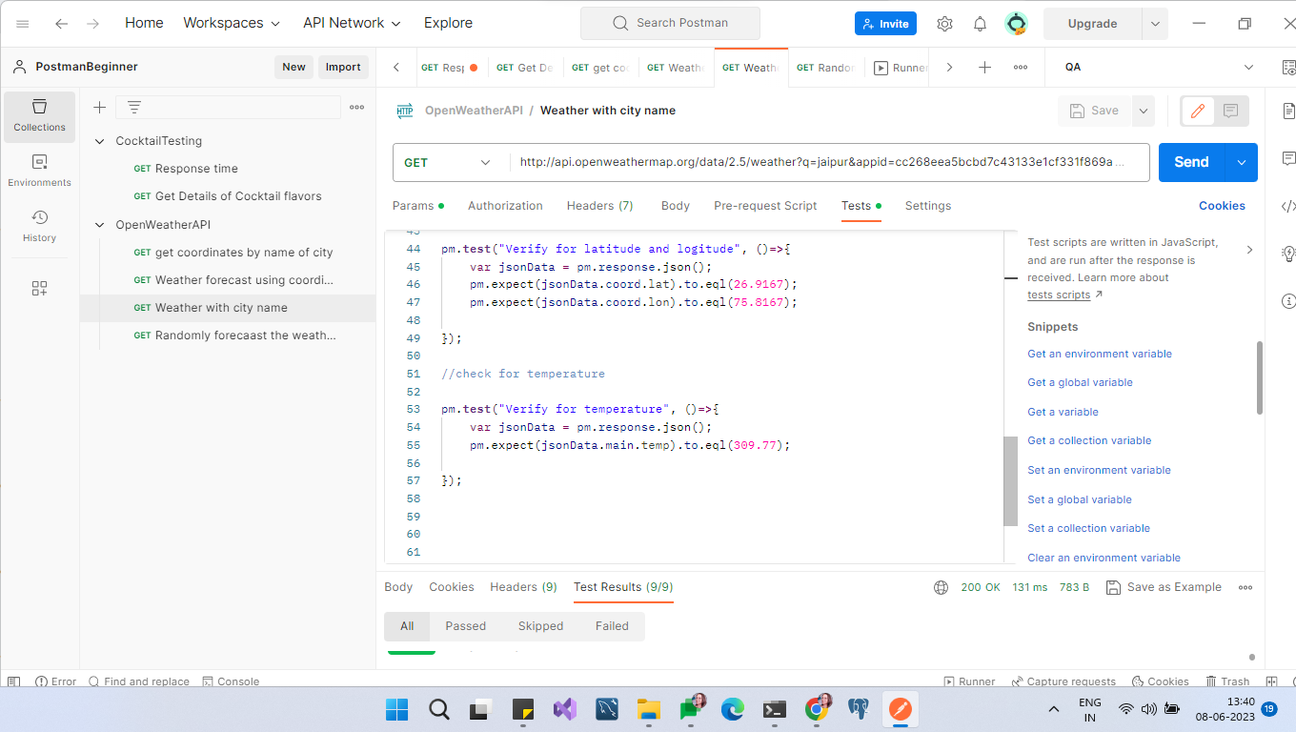

**Assignment 4:**

1. Run the collection created above through Newman.

==export the environment and the collection in json format to a folder .

== set up the directory to the folder created

==Provide the name of both the json files in below command



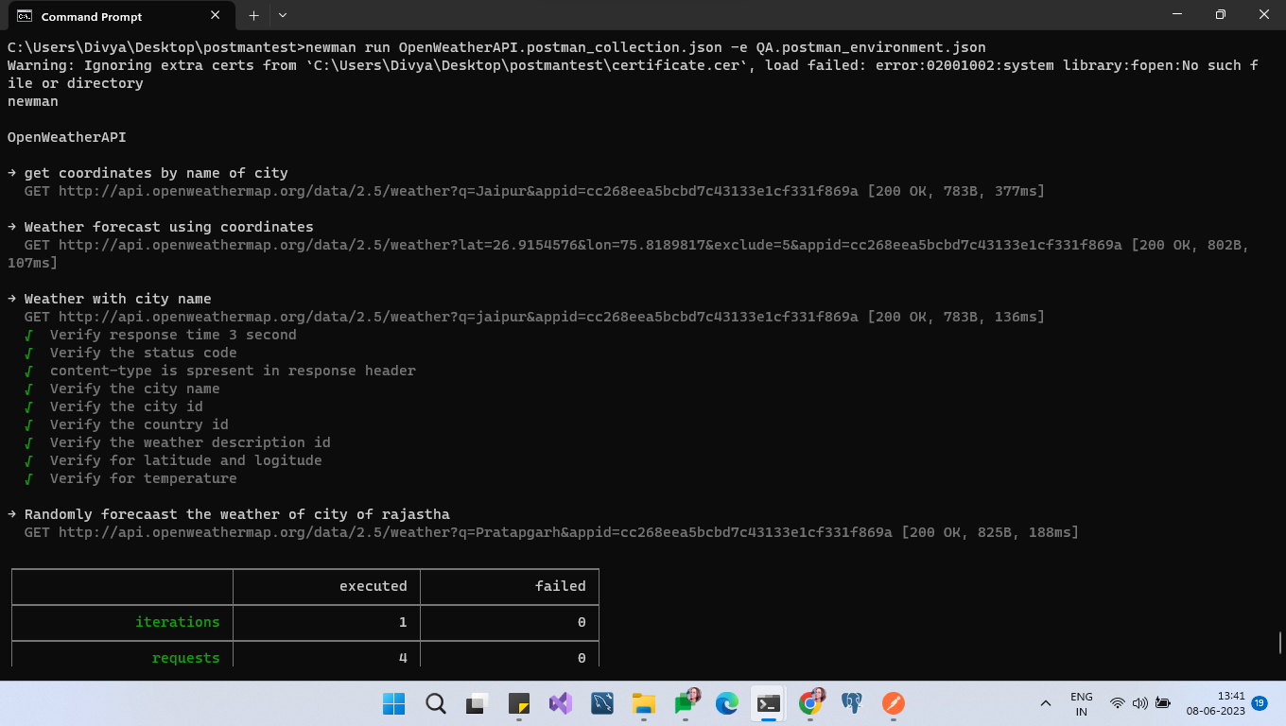

2. Newman should generate HTML Reports.

